EXPERIMENT : 10

CREATE TABLE Bank ( BankID NUMBER(3) PRIMARY KEY, bankname VARCHAR(100),

headoffice VARCHAR(100), branch VARCHAR(100), branchcode NUMBER(5) );

table BANK created.

INSERT INTO Bank VALUES (1, 'State Bank of India', 'Mumbai', 'Alappuzha', 101);

INSERT INTO Bank VALUES (2, 'HDFC Bank', 'Trivandrum', 'Kottayam', 102);

INSERT INTO Bank VALUES (3, 'ICICI Bank', 'Mumbai', 'Ernakulam', 103);

INSERT INTO Bank VALUES (4, 'Axis Bank', 'Mumbai', 'Palakkad', 104);

INSERT INTO Bank VALUES (5, 'Punjab National Bank', 'New Delhi', 'Kollam', 105);

5 rows inserted.

select * from Bank;

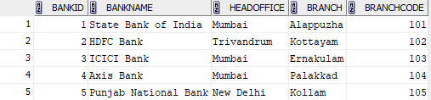

commit;

committed.

savepoint A;

savepoint A

delete from Bank where BankID = 1;

1 rows deleted.

select * from Bank;

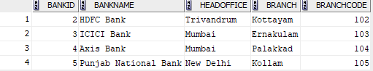

rollback to savepoint A;

rollback complete

select * from Bank;

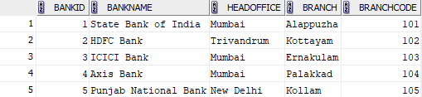

UPDATE Bank SET branch = 'Kochi' WHERE bankname = 'State Bank of India';

1 rows updated.

select * from Bank;

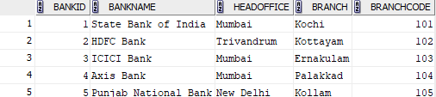

rollback;

rollback complete

select * from Bank;

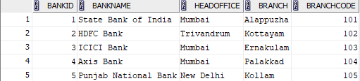

**EXPERIMENT : 11**

CREATE TABLE Bank ( BankID NUMBER(3) PRIMARY KEY, bankname VARCHAR(100),

headoffice VARCHAR(100), branch VARCHAR(100), branchcode NUMBER(5) );

INSERT INTO Bank VALUES (1, 'State Bank of India', 'Mumbai', 'Alappuzha', 101);

INSERT INTO Bank VALUES (2, 'HDFC Bank', 'Trivandrum', 'Kottayam', 102);

INSERT INTO Bank VALUES (3, 'ICICI Bank', 'Mumbai', 'Ernakulam', 103);

INSERT INTO Bank VALUES (4, 'Axis Bank', 'Mumbai', 'Palakkad', 104);

INSERT INTO Bank VALUES (5, 'Punjab National Bank', 'New Delhi', 'Kollam', 105);

select * from Bank;

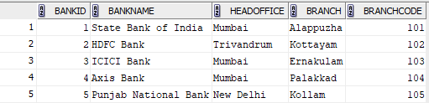

**GRANT**

GRANT SELECT ON Bank TO c22csa46;

GRANT succeeded.

SELECT * FROM c22csa46.Bank;

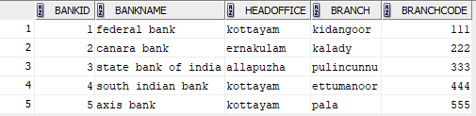

**REVOKE**

REVOKE SELECT ON Bank FROM c22csa46;

REVOKE succeeded.

SELECT * FROM c22csa46.Bank;

ORA-00942: table or view does not exist

00942. 00000 - "table or view does not exist"

*Cause:

*Action: Error at Line: 1 Column: 24

**GRANT**

GRANT SELECT,UPDATE ON Bank TO c22csa46;

GRANT succeeded.

UPDATE c22csa21.Bank SET BRANCH = ‘Kottayam’ WHERE bankname = ‘Punjab National Bank’;

Commit;

select * from Bank;

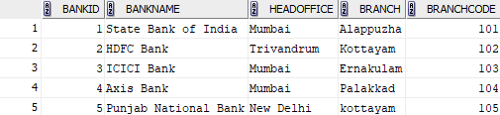

**REVOKE**

REVOKE SELECT,UPDATE ON Bank FROM c22csa46;

REVOKE succeeded.

SELECT * FROM c22csa46.Bank;

ORA-00942: table or view does not exist

00942. 00000 - "table or view does not exist"

*Cause:

*Action: Error at Line: 1 Column: 24